

FACULTY OF ELECTRONICS

COMPUTER ENGINEERING AND TELECOMMUNICATIONS DEPARTMENT

LABORATORY WORK #8

Modeling 4G Mobile Coverage Optimisation

Student: Mark Mikula

Teacher: Artūras Medeišis

Vilnius, 2025

Objective: This lab involves modeling 4G mobile coverage using ArcGIS. It provides insight into cell tower installation planning

Tools Used: ArcGIS

The lab utilizes a previous project (Lab 7) for the working environment

First, we create cells, see their signal coverage, modify the view. After seeing problems with coverage, we create a second cell, which will improve it.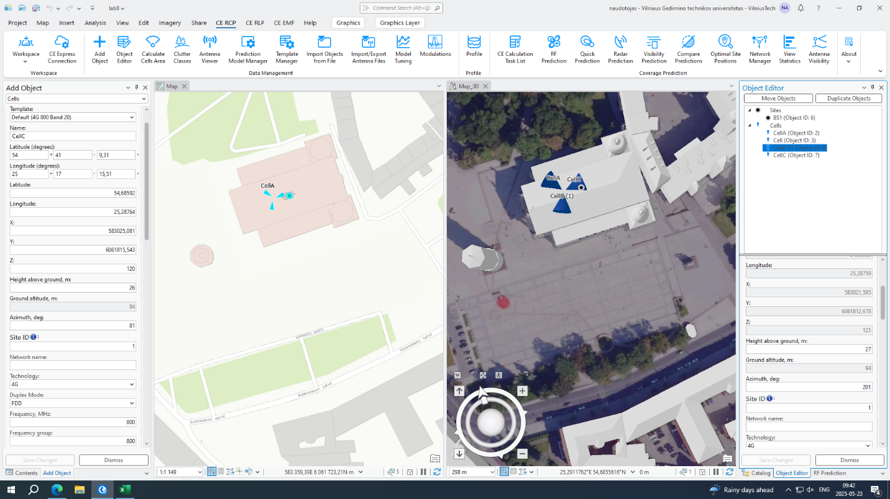 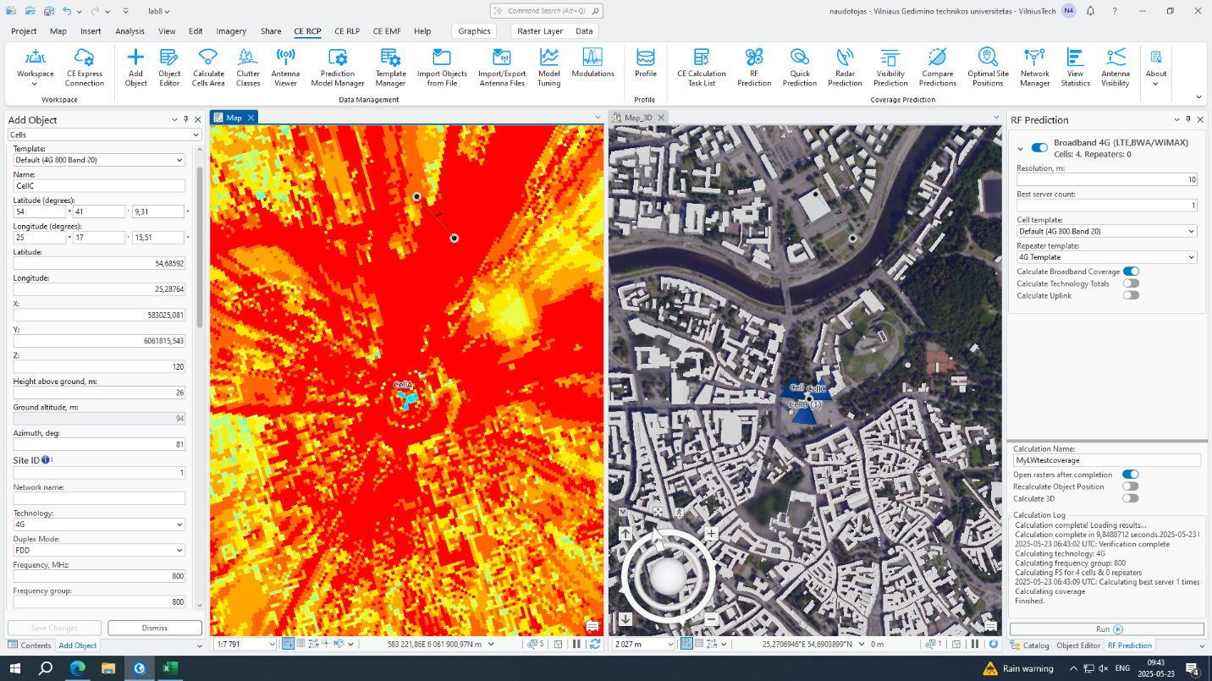 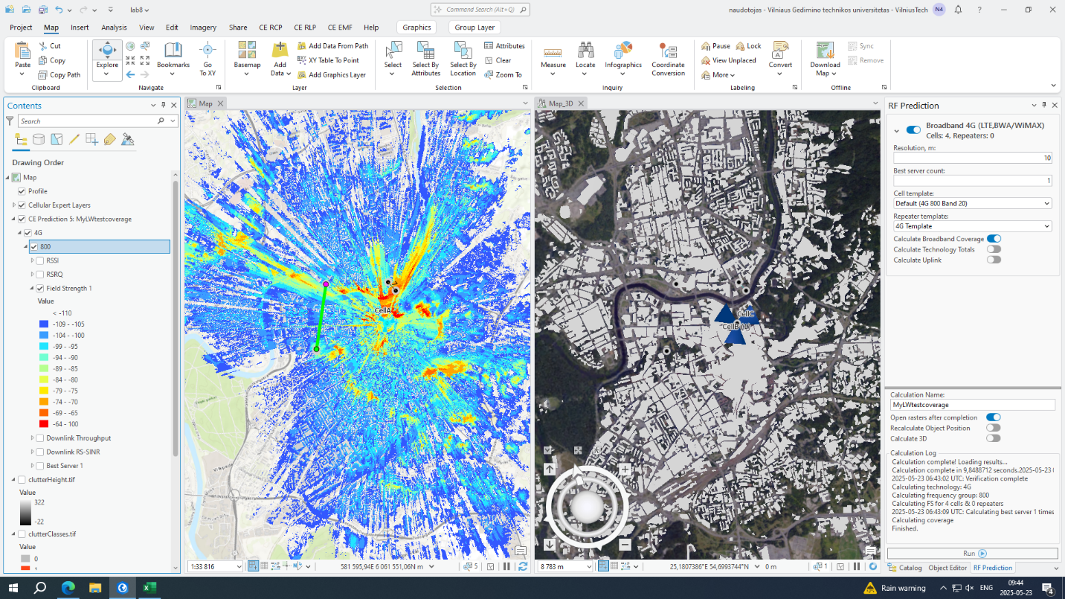 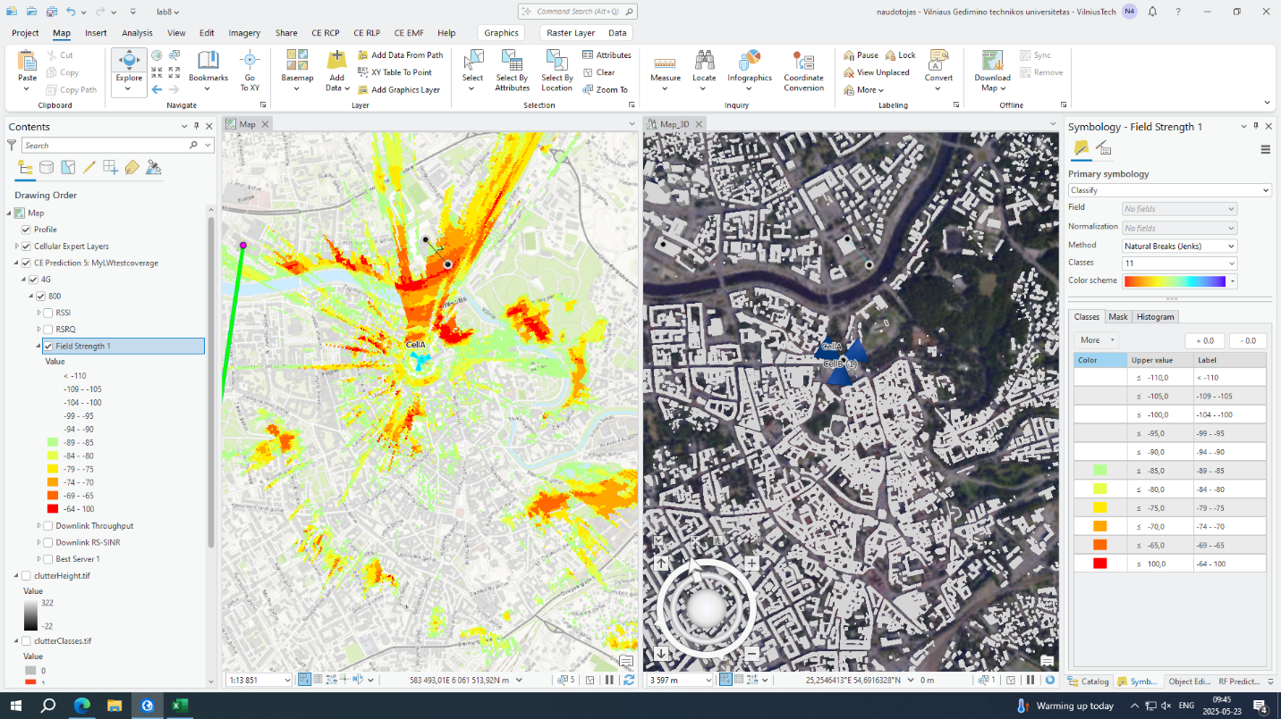 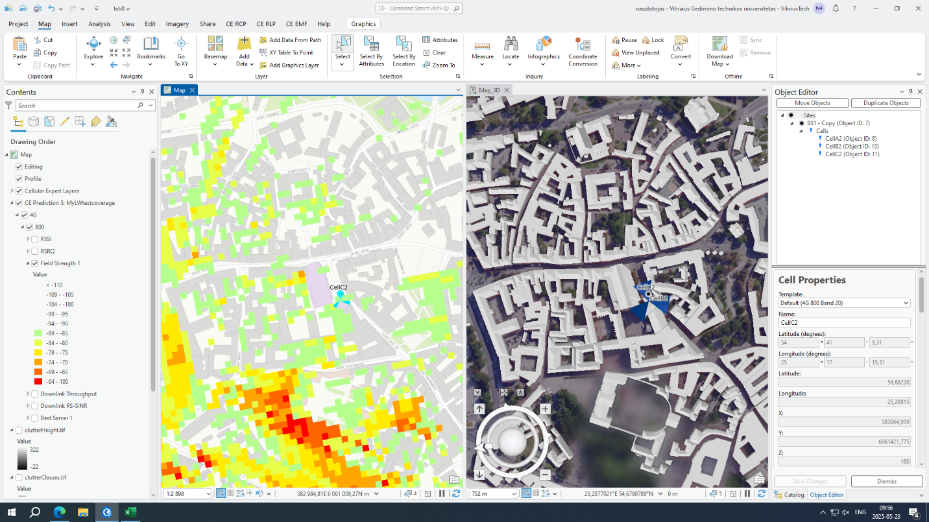

Here, we can see difference between one cell coverage, and two cells combined coverage